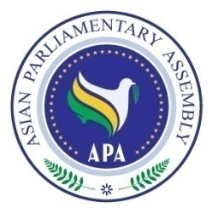

APA Cooperation and Coordination Committee Meeting
At the side of
137th IPU Assembly

Saturday, 14 October 2017
9.00 – 11.00 a.m.
Hall No. 16, on the ground floor of the Tavrichesky Palace
(Venue of the 137th IPU Assembly)

Draft Agenda

- Adoption of the Agenda
- Statement of APA Secretary-General
- Briefing on the working program by candidates of IPU presidency
- Consideration of the Emergency items on the IPU Agenda
- Any other matter.

